Information Systems & Information Management
An Example of Homework

Group Member:
Finish Date:

Homework 1: Design of Information Systems
1. System Description
Yuanke Company is a technology company in the early stage of its development. Due to the limited operating capital of the company, it did not hire specialized IT personnel. Instead, its business employees developed a flexible and practical travel management system through a low-code platform.
The travel management system mainly involves approval processes and financial processes. The personnel and department roles involved in the travel management system include travelers, offices, finance departments, department managers, and general managers. The approval process mainly includes the traveler's application, department manager's approval, and general manager's approval. The financial process mainly includes whether the office has booked tickets, financial budgets, whether to borrow money, reimbursement settlement, and other aspects.
2. System function diagram
The system mainly includes the following functions: travel application, travel approval, historical approval view, and travel data summary. The system functional structure diagram is shown below:
travel management system
travel application
travel approval
historical approval view
travel data summary
Fig 1-1, System function diagram
3. Design and Descriptions of Business Processes
The organizational structure involved in the travel system is divided into two levels: company and department. The company level has a sales department, a finance department, and an office. The company has a general manager position, and each department has a department manager position. The system approval process is set as follows:
1. The travel form for ordinary employees needs to be approved by the department manager of the department and then by the general manager;
2. The travel form of the department manager needs to be approved by the general manager;
3. The approval process for the General Manager's travel form will be automatically skipped.
The business process diagram is shown below:
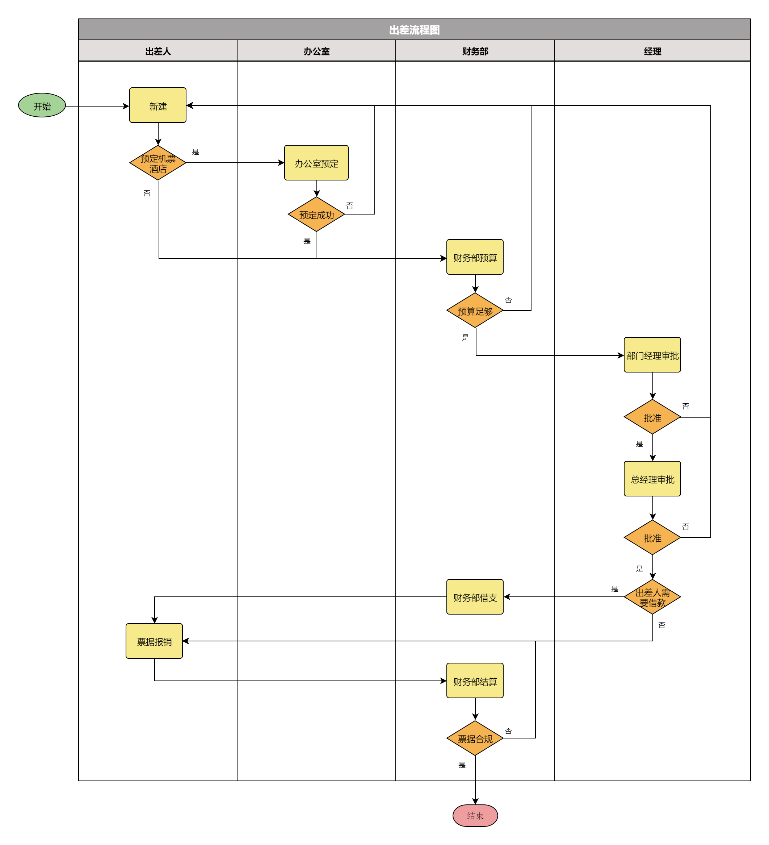
Fig 1-2. Business Process
4. System Development and Interfaces
This system is developed using the "Live Grid" low-code development platform. The system login interface is shown below:
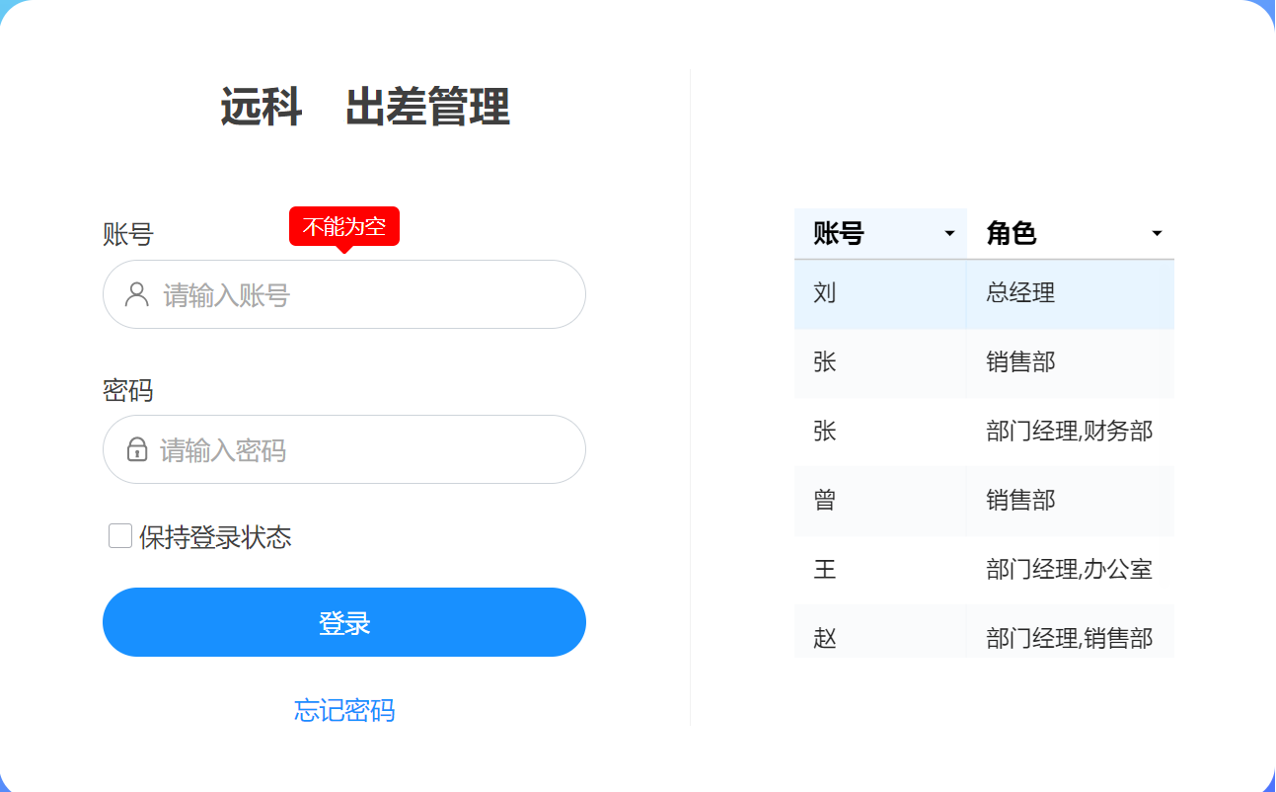
Fig 1-3, Login Interface
The travel approval process flow chart in the system is shown in the following figure:
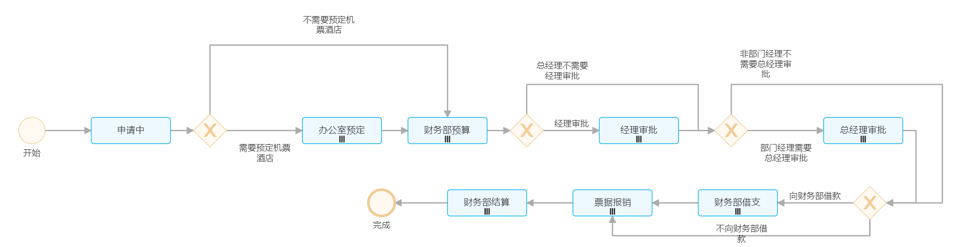
Fig 1-4, Approval Process

Some functional interfaces of the system are shown in the figures below:
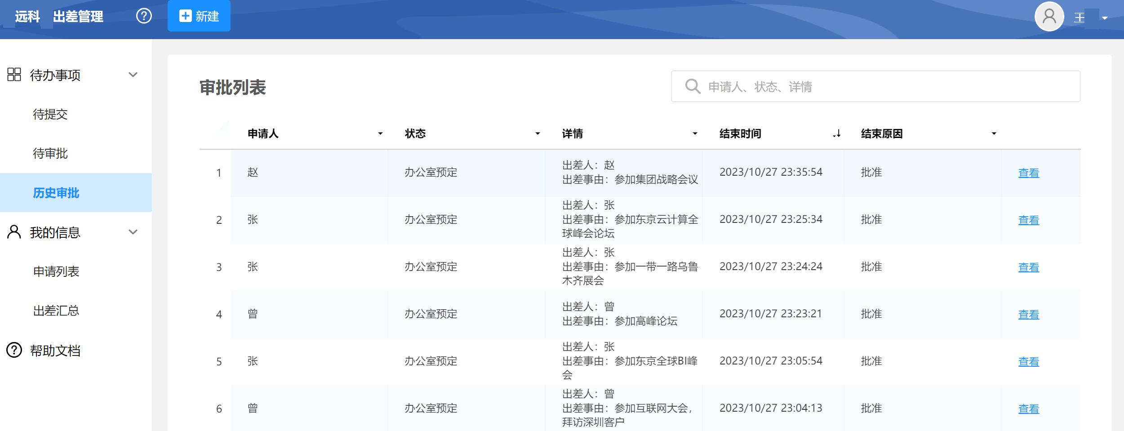
Fig 1-5, functional interfaces

5. Summary (An Example, Please DO NOT Copy and Paste)
Through the practice of this assignment, we have initially mastered the basic logic of low-code/zero-code system development and have a certain understanding of low-code platforms. On the one hand, the systems developed by low-code/zero-code platforms can meet the needs of most processes; on the other hand, although it is low-code or zero-code, it still requires a lot of learning and experimentation to design a system with practical significance.

Homework 2: Data Analysis and Decision Support
1. Data Description
The data used in this report is a meal record. The sample is shown in Table 2-1. The data consists of 6 columns and 93,279 entries. The data is fictional based on real meal records. Among them, the meal time (transtime) and amount (transvalue) are real, and the other fields are fictional.
Table 2-1, Mean Record
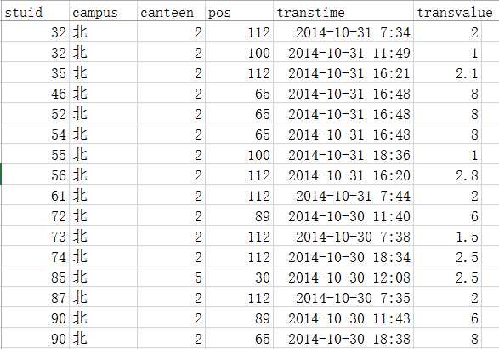
2. Exploring the Dinning Patterns
By analyzing the number of daily diners, it can be found that the number of diners from Monday to Friday is significantly higher than that of Saturday and Sunday. Holidays (such as National Day) have a significant impact on the number of diners.
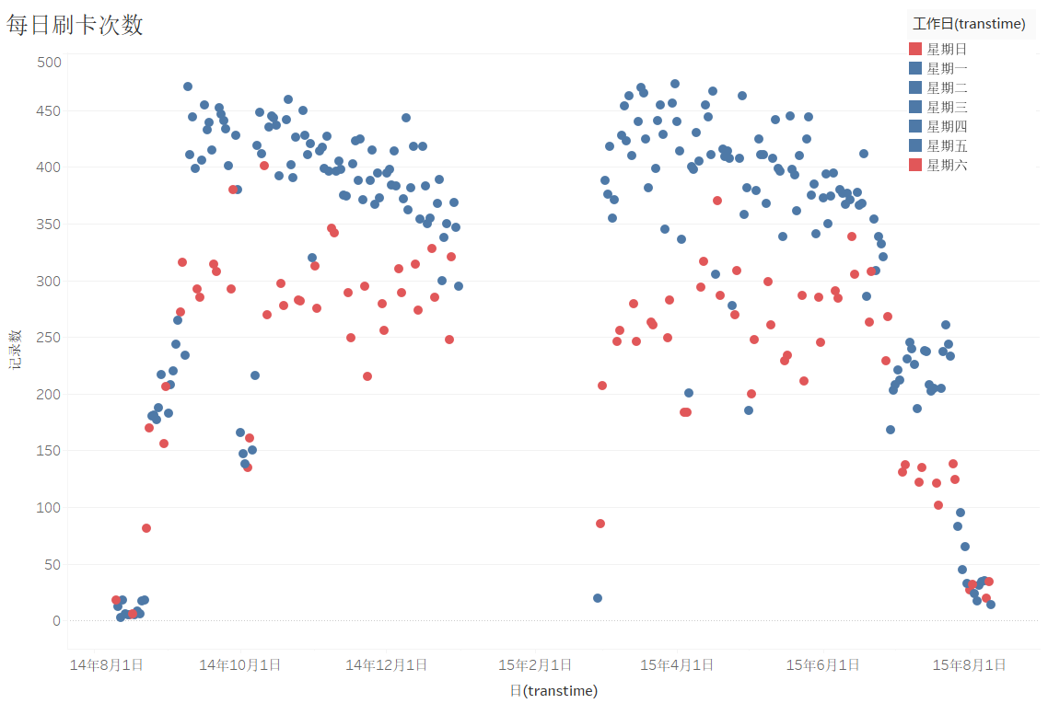
Fig 2-1, Number of Meals
Figure 2-2 shows the dining habits of undergraduate students. It can be seen that there are three peaks for breakfast, namely 7:05, 7:40, and 9:55; there are two peaks for lunch, namely 12:05 and 11:40. Dinner is at 17:30 and 18:05. Due to the difference in work schedules between winter and summer, there is a small peak around 18:35.
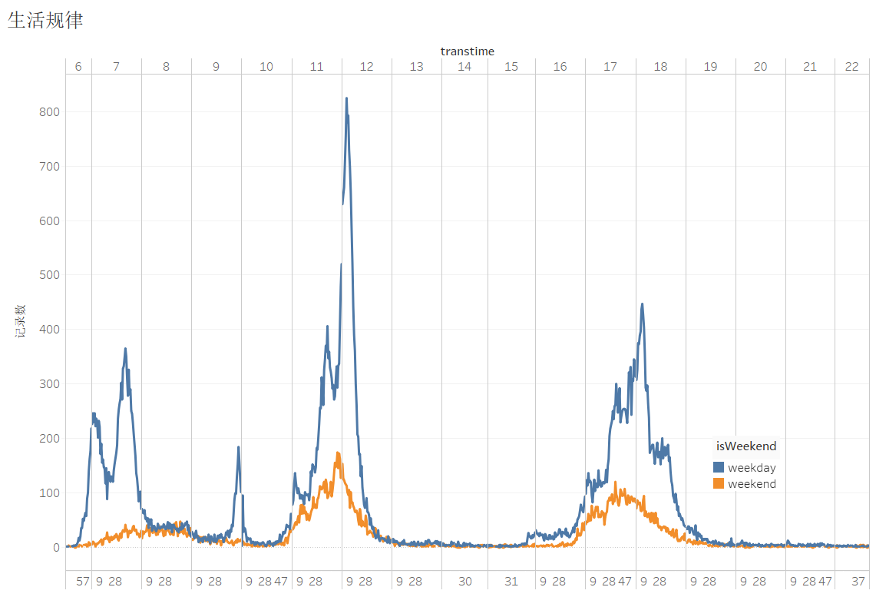
Fig 2-2, Daily Meal Pattern
3. Meal Preference
By calculating the number of card swipes on each POS machine, it can be seen that some POS machines have a high number of swipes, while others have almost no customers. Further analysis using two-dimensional table technology to analyze the working hours of each POS machine (as shown in Figure 2-3) reveals that some POS machines do not have stable sales behavior, as the POS number is fictitious.
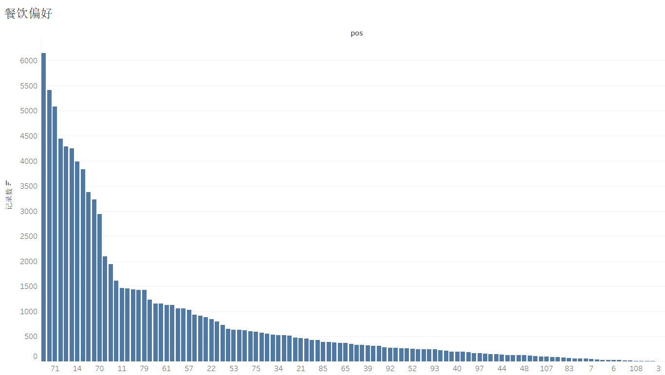
Fig 2-3, Number of Meals on Each POS Terminal

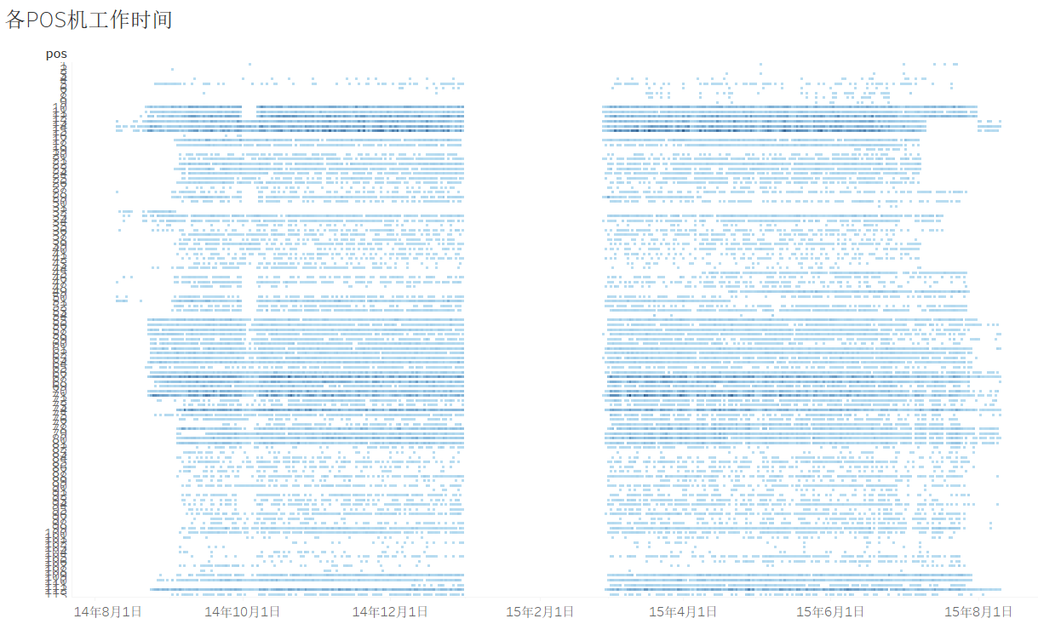
Fig 2-4, Number of Meals on Each POS Terminal in Each Day

4. Analysis of Students’ Meal Behavior
Analyzing the daily meal situation of each student, it can be seen that there is a certain regularity in students' meal behavior. For example, there are fewer students who eat during the summer and winter vacations, and fewer meals on National Day. At the same time, several students who eat less at school have been identified. The correlation between with their grades shows that their grades are poor.
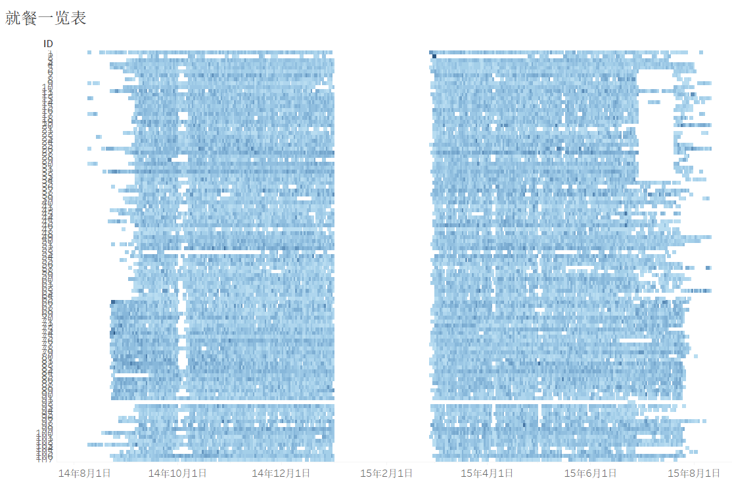
Fig 2-5, Number of Meals of Each Student in Each Day

Via analyzing the association between each student and POS machine, we can see that some students have fixed dining preferences. For example, student No. 99 swiped his card 482 times on POS machine No. 12, averaging more than twice a day.
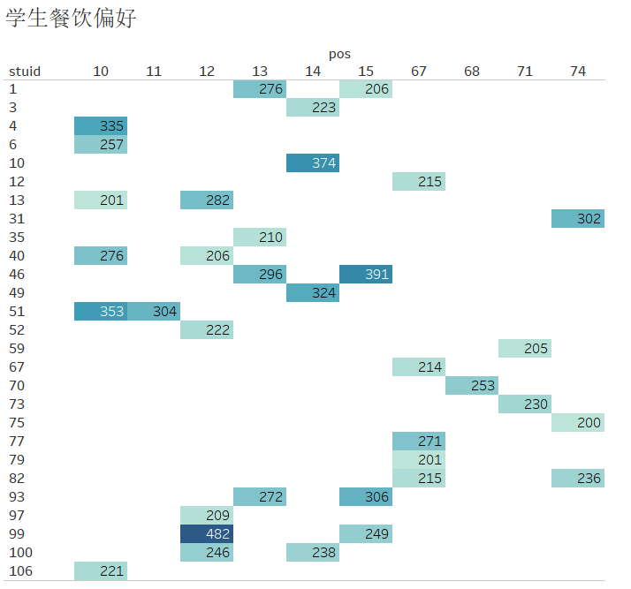
Fig 2-6, Meal Preference

5. Summary (An Example, Please DO NOT Copy and Paste)
Through the study of Tableau and other software, we found that low-code data analysis tools can quickly carry out certain data analysis, with low technical barriers and easy to learn and master. In the practical process, we also found that how to cut into the data and discover the rules in the data requires repeated practice to improve our ability and level.

